Analysis of Firms Experiment

Elea McDonnell Feit

1/18/2018

# Data

The data describes an experiment where respondents where given a story about a company that either did or did not take a stand regarding an abortion-related law. Each row describes the story that was given to the repondent and their evaluation of the company.

* **stand** of a firm with respect to the law was either “against”, “for” or “none” (randomly manipulated)
* **firm.value** was either “results”-oriented or “values”-oriented (randomly manipulated)
* **hypocricy** is a measure of the level of perceived corporate hypocrisy. It is a composite of three perceived hypocrisy scale items.
* **purchase_int** is the composite score of three purchase intention scale items.
* **age** is the age of the respondent.
* **gender** is the gender of the respondent.

d <- read.csv("firms.csv")  
d$stand <- as.factor(d$stand)  
d$firm.value <- as.factor(d$firm.value)  
d$gender <- as.factor(d$gender)  
summary(d)

## stand firm.value hypocrisy purchase_int   
## against :58 results:85 Min. :1.000 Min. :1.000   
## for :59 values :88 1st Qu.:1.330 1st Qu.:3.330   
## no stand:56 Median :2.330 Median :4.330   
## Mean :2.917 Mean :4.235   
## 3rd Qu.:4.000 3rd Qu.:5.670   
## Max. :7.000 Max. :7.000   
## age gender   
## Min. :19.00 female:82   
## 1st Qu.:28.00 male :91   
## Median :33.00   
## Mean :37.43   
## 3rd Qu.:46.00   
## Max. :69.00

# Outliers

After inspecting the data, we realized that observation 30 was incorrectly collected, so we remove them.

d <- d[-30,]  
summary(d)

## stand firm.value hypocrisy purchase_int   
## against :58 results:85 Min. :1.000 Min. :1.000   
## for :58 values :87 1st Qu.:1.330 1st Qu.:3.248   
## no stand:56 Median :2.330 Median :4.330   
## Mean :2.921 Mean :4.225   
## 3rd Qu.:4.000 3rd Qu.:5.670   
## Max. :7.000 Max. :7.000   
## age gender   
## Min. :19.00 female:82   
## 1st Qu.:28.00 male :90   
## Median :33.00   
## Mean :37.43   
## 3rd Qu.:46.00   
## Max. :69.00

# Analysis

We hypothesize that when values-oriented (versus results-oriented) companies abstain from taking a political stand, consumers perceive them to be hypocritical. This, in turn, will lead to lower purchase intention for the products offered by those companies. Based on this hypothesis, we created a new variable indicating whether the firm was described as taking a stand.

d$stand.yn <- as.character(d$stand)  
d$stand.yn[d$stand.yn=="against" | d$stand.yn=="for"] <- "stand"  
d$stand.yn <- as.factor(d$stand.yn)  
summary(d$stand.yn)

## no stand stand   
## 56 116

When value-oriented companies fail to take a stand, they are perceived as hypocritical

boxplot(hypocrisy ~ stand.yn + firm.value, data=d, main="Hypocrisy", ylab="composite hypocrisy score")

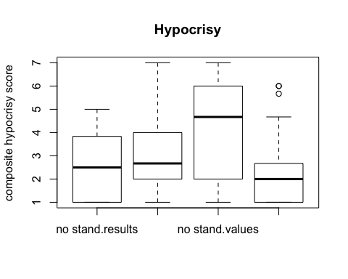

Statistical significance of the interaction between stand.yn and firm.value is confirmed by ANOVA.

m1 <- lm(hypocrisy ~ stand.yn*firm.value, data=d) # interactions  
anova(m1)

## Analysis of Variance Table  
##   
## Response: hypocrisy  
## Df Sum Sq Mean Sq F value Pr(>F)   
## stand.yn 1 26.78 26.777 10.312 0.001584 **   
## firm.value 1 0.28 0.280 0.108 0.742879   
## stand.yn:firm.value 1 70.48 70.481 27.143 5.479e-07 ***  
## Residuals 168 436.24 2.597   
## ---  
## Signif. codes: 0 '***' 0.001 '**' 0.01 '*' 0.05 '.' 0.1 ' ' 1

Similarly, purchase intent is lower for those value-oriented firms who do not take a stand.

boxplot(purchase_int ~ stand.yn + firm.value, data=d, main="Hypocrisy", ylab="composite hypocrisy score")

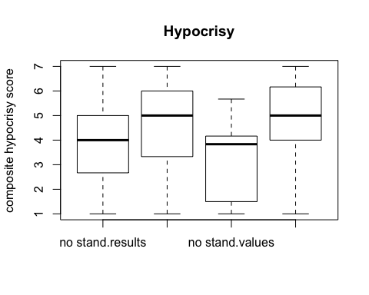

m2 <- lm(purchase_int ~ stand.yn*firm.value, data=d)  
anova(m2)

## Analysis of Variance Table  
##   
## Response: purchase_int  
## Df Sum Sq Mean Sq F value Pr(>F)   
## stand.yn 1 45.03 45.032 15.4677 0.0001226 ***  
## firm.value 1 0.33 0.326 0.1120 0.7382599   
## stand.yn:firm.value 1 9.01 9.013 3.0957 0.0803179 .   
## Residuals 168 489.11 2.911   
## ---  
## Signif. codes: 0 '***' 0.001 '**' 0.01 '*' 0.05 '.' 0.1 ' ' 1

I also did some simple t-tests for fun.

t.test(d$hypocrisy[d$stand.yn=="no stand"], d$hypocrisy[d$stand.yn=="stand"])

##   
## Welch Two Sample t-test  
##   
## data: d$hypocrisy[d$stand.yn == "no stand"] and d$hypocrisy[d$stand.yn == "stand"]  
## t = 2.8295, df = 94.394, p-value = 0.005696  
## alternative hypothesis: true difference in means is not equal to 0  
## 95 percent confidence interval:  
## 0.2511821 1.4328696  
## sample estimates:  
## mean of x mean of y   
## 3.488750 2.646724

p1 <- t.test(d$hypocrisy[d$stand.yn=="no stand"], d$hypocrisy[d$stand.yn=="stand"])$p.value  
t.test(d$purchase_int[d$stand.yn=="no stand"], d$purchase_int[d$stand.yn=="stand"])

##   
## Welch Two Sample t-test  
##   
## data: d$purchase_int[d$stand.yn == "no stand"] and d$purchase_int[d$stand.yn == "stand"]  
## t = -4.0552, df = 118.91, p-value = 8.985e-05  
## alternative hypothesis: true difference in means is not equal to 0  
## 95 percent confidence interval:  
## -1.6251405 -0.5587635  
## sample estimates:  
## mean of x mean of y   
## 3.488393 4.580345

t.test(d$hypocrisy[d$firm.value=="results"], d$hypocrisy[d$firm.value=="values"])

##   
## Welch Two Sample t-test  
##   
## data: d$hypocrisy[d$firm.value == "results"] and d$hypocrisy[d$firm.value == "values"]  
## t = 0.32293, df = 168.54, p-value = 0.7471  
## alternative hypothesis: true difference in means is not equal to 0  
## 95 percent confidence interval:  
## -0.4454813 0.6197315  
## sample estimates:  
## mean of x mean of y   
## 2.964941 2.877816

t.test(d$purchase_int[d$firm.value=="results"], d$purchase_int[d$firm.value=="values"])

##   
## Welch Two Sample t-test  
##   
## data: d$purchase_int[d$firm.value == "results"] and d$purchase_int[d$firm.value == "values"]  
## t = -0.34981, df = 169.79, p-value = 0.7269  
## alternative hypothesis: true difference in means is not equal to 0  
## 95 percent confidence interval:  
## -0.6335379 0.4428063  
## sample estimates:  
## mean of x mean of y   
## 4.176588 4.271954

The first test is significant at p= 0.0056958.

# Sample characteristics

The sample contains similar numbers of men and women.

summary(d$gender)

## female male   
## 82 90

plot(d$gender)

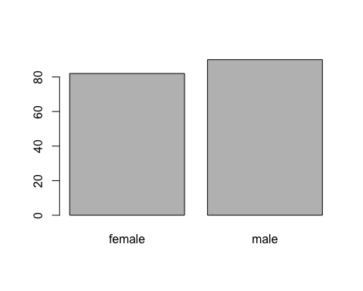

The distribution of age is typical for mTurk.

summary(d$age)

## Min. 1st Qu. Median Mean 3rd Qu. Max.   
## 19.00 28.00 33.00 37.43 46.00 69.00

hist(d$age, main="Histogram of Respondent Age")

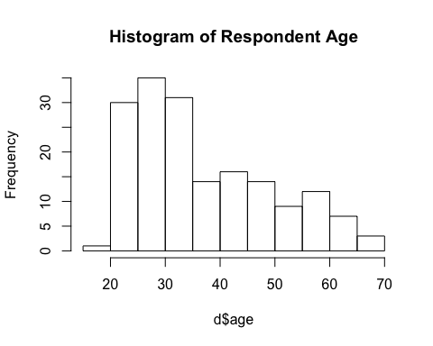

# Randomization check

The proportion of women in each of the 6 (= 2 x 3) randomized treatments is similar with one exception.

xtabs(~ gender + stand + firm.value, data=d)

## , , firm.value = results  
##   
## stand  
## gender against for no stand  
## female 9 15 14  
## male 17 16 14  
##   
## , , firm.value = values  
##   
## stand  
## gender against for no stand  
## female 15 15 14  
## male 17 12 14

plot(xtabs(~ gender + stand + firm.value, data=d))

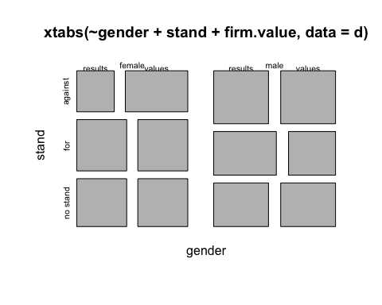 The distribution of age is similar across the randomly assigned treatments, confirming that the randomization looks okay.

aggregate(age ~ stand + firm.value, data=d, FUN=mean)

## stand firm.value age  
## 1 against results 39.15385  
## 2 for results 38.06452  
## 3 no stand results 37.35714  
## 4 against values 34.15625  
## 5 for values 38.96296  
## 6 no stand values 37.46429

plot(aggregate(age ~ stand, data=d, FUN=mean), ylim=c(15,80))

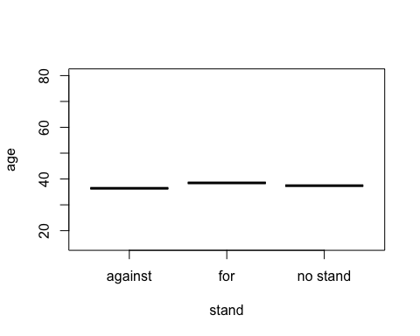

plot(age ~ stand, data=d)

